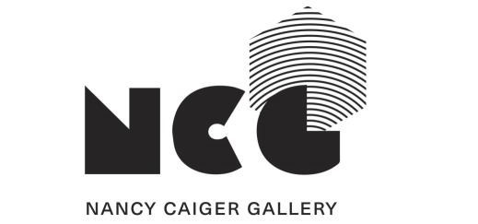

EXHIBITION INFORMATION PACK
NANCY CAIGER GALLERY, THE METEOR THEATRE

The Nancy Caiger Gallery (NCG) is located at The Meteor Theatre, 1 Victoria Street, Kirikiriroa
Hamilton. Operated by the One Victoria Trust, our vision is to foster, develop, and encourage all forms of creative art, providing a vibrant and thriving venue that benefits the community.

In addition to being open Wednesday to Saturday 11am - 2pm, the gallery is also open before shows and by appointment. Exhibitions usually run for three to four weeks and can either be solo or group shows.

PROPOSAL INFORMATION
Exhibitions in the NCG have a weekly fee of $50 +GST and this is in addition to a 20% commission taken upon sale of work. Artwork sales (less commission) will be paid to the artist(s) at the end of the exhibition period.
Exhibitions are hung by curation with prior agreement and will usually involve the exhibiting artist(s) as the primary installer. Any large-scale changes to the space and/or sound installations must be stated in your exhibition proposal. Any works that require special handling must also be communicated in advance.
All unsold work must be collected within 5 working days from the close of the exhibition unless negotiated prior to the start of the exhibition.
If artist(s) withdraws their exhibition proposal after the agreement form has been signed a fee will be incurred. The artist(s) will need to pay 50% of the gallery hire fee if the exhibition is cancelled within 4 weeks of the agreed opening date.

EXHIBITION OPENINGS
Exhibition opening events are scheduled to best fit with The Meteor programmed events. Any alcohol served at opening events must be purchased through The Meteor. As a licensed venue we will also provide an on-site Duty Manager for the service of alcohol.

FLOOR PLAN

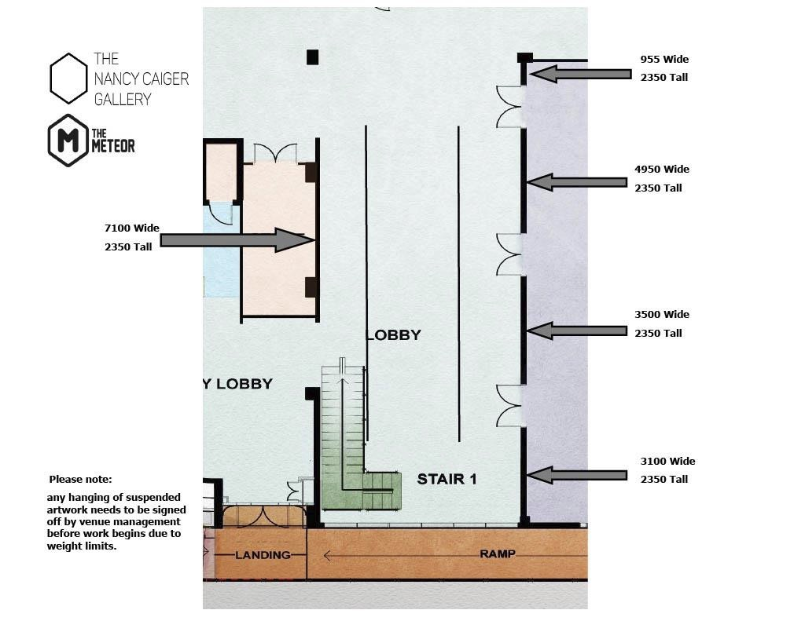

TERMS AND CONDITIONS

Artist responsibilities:
- Have exhibited works available for sale (unless otherwise agreed with NCG).
- Return all requested documents and information within the required timeframes.
- Supply 3-5 high resolution colour digital images (jpegs) of the work to be exhibited, labelled with title, medium, size and date.
- Supply an artist bio, artist statement and exhibition description (each 150 words) to be used for marketing purposes.
- Supply an A0 exhibition poster to be displayed in NCG. The NCG and Meteor logos must be included on all advertising.
- Provide installation details/requirements four weeks prior to the exhibition start date.
- Any changes to the agreed proposal or arrangements must be discussed with The Meteor staff a minimum of two weeks prior to the exhibition start date.
- Deliver all works to NCG ready for installation on the agreed date (labelled with artist, title, medium, size and date, and ready for hanging or display).
- Pay a 25% deposit of the total exhibition fee on signing of the exhibition agreement.
- Arrange insurance appropriate for the works while they are on NCG premises and in transit.
Collect any unsold work from NCG within five working days of the end of the exhibition.
- Pay the remainder of the exhibition fee no later than one week past the exhibition close date.
- The Artist (or representative from a group exhibition) needs to invigilate the exhibition for a minimum of one day per week.
- The Artist agrees to comply with the Health & Safety guidelines as set out by The Meteor Health and Safety policy.
Nancy Caiger Gallery responsibilities:
- Advertise the exhibition via The Meteor website
- Promote the exhibition on social media for both the NCG and The Meteor.
- Design a price list for the exhibition and display this in the gallery space.
- Assist the artist with installation and deinstallation of works.
- Handle works with care while they are within the NCG.
- Offer an exhibition opening on a mutually agreeable date.
- Provide an on-site Duty Manager for the service of alcohol during any private events.
- Allow the exhibition to be available in the event of a private viewing request.

If you would like to discuss any aspects of your exhibition proposal prior to submission, please email us at ncgallery@themeteor.co.nz. We look forward to receiving your exhibition proposal.

